## ABOUT US

Digival Solutions is one of the leading 360 ° full-service marketing agencies. Our services, our ideas, our vision and our actions always have one goal that we want to reach your strategic goals together with you.We lead you to success by fulfilling your visions! We create a positive image, bring in new customers and increase your sales. We take the complete realization into our hands and give support to your projects in the areas of marketing and communication.

##### WE HEAR YOUR WISHES, WE PLAN ACCURATELY, WE DESIGN, PUBLISH AND MONITOR

Together, we work on your success by carefully examining your company’s skills and work out on strengths and weaknesses in a very targeted manner. After having this analysis done together with the actual need for optimization, we determine your individual digital strategy and show which communication channels really make sense for your company. Naturally, we also incorporate your very specific requirements and needs into the project process and with regular monitoring, we achieve the desired success without detours.

##### SAVE TIME AND MONEY BY FULLY RELYING ON DIGIVAL SOLUTIONS

We are way ahead of our competitors because we plan to meet your budgetary needs and provide 24-hour customer service 7 days a week. With us you are never on your own!

We are excited to meet you and look forward to hearing from you!

1.REDESIGN

EXTEND WEBSITE FUNCTIONALITY

Your website can do more than you think. We'll show you what else you can get out of your page. With a new upgraded redesign plan, we create your website on the latest technical and graphical stand. The modernization of your website also increases the usability. Of course, to achieve this ease of use, we need to work on the site structure. It is not just about the visual impression of the site for which a new web design is needed, but above all it's about how well the performance of the page is: Is it fast enough? Does it correspond to the target audience?

WHEN A REDESIGN IS NECESSARY

A successful website informs the customer about products and services and ensures optimal customer contact. Entrepreneurs are not always satisfied with their website: either the performance is not right or there are too many weaknesses or the company has changed its philosophy. However, before deciding on the big step of a redesign, not to be confused with the re-brand, one should thoroughly test the site. Find out what customers think about your site and whether it really appears bad. Think about what you've changed about the products and services, what new features the site should have and what the exact aim of the redesign should be. Only when these important points are precisely defined in one or more counseling sessions, we begin the planning process. The design plays an elementary role in the redesign, because this defines your company significantly outside. Design stands on a level with image, user-friendliness and acceptance, because after all, a lasting positive impression should be left with the customer. Of course, the designs are always created and revised by having a deep discussion with you. The optimal technical implementation and modernization as well as simplification of the website plays a very important role in the redesign. The usability of the website is never as important as it is today.

CONCLUSION

Whether you want to do a major overhaul of your website or just modernize or customize a few things, you need to think carefully to make important decisions as early as possible to save time and money. The end result, which you expect from the redesign, must be defined transparently and clearly.

We look forward to a joint consultation with you. Contact us today!

##### 2.WORDPRESS KNOW HOW on the fast!

WordPress is one of the simplest and incredible platforms which manages 100 million plus websites worldwide. It is the powerful platform which can easily manage your site and allows you to make the website live within a few moments. Many bloggers, business owners opt for WordPress to create their site.

Digival Solutions has expertise in developing sites using WordPress. We have a team of highly skilled WordPress developers and designers who are proficient in every aspect of WordPress.

At Digival Solutions, we believe in providing you a complete web solution, and hence work as per your requirement only. We listen to your requirement, understands your need, plan accordingly, and then only we start working.

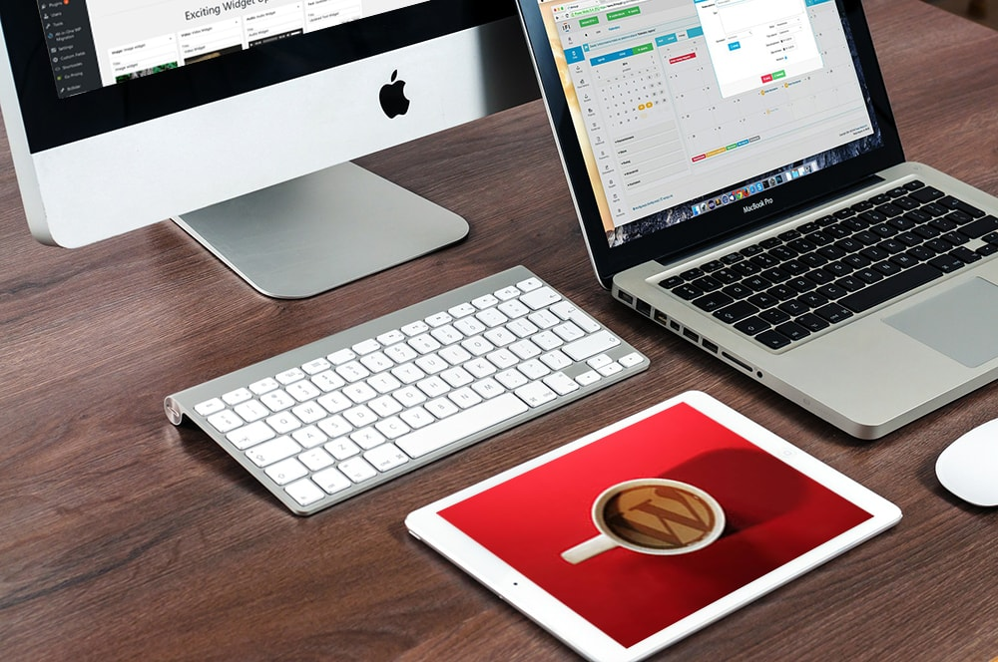

##### We Provide Following Services in WordPress:

* Website Development and Designing in WordPress.
* WordPress Installation Setup.
* Responsive WordPress Sites.
* Slider Integration in WordPress sites.
* WordPress Theme Installation.
* PSD to WordPress.

##### 3.CONTENT MANAGEMEMT SYSTEM:

##### EASY MANAGEMENT WITH CMS

Nowadays, it is important that a website is always up-to-date, the obsolete or even faulty content on your website is unforgivable. For this reason, no website can ignore a good Content Management System (CMS). Maintaining a website up-to-date is a breeze for inexperienced web users using a CMS, as it's intuitive to use and does not require any prior technical knowledge. This does not require a lot of training, most of the time users can work independently with the system after just one hour of training and maintain the home page. With this system you can manage practically all contents of your website independently: You can create new pages, change navigations, maintain databases, insert texts and pictures. You'll be amazed at how quickly and easily you can keep your websites up-to-date with this system whether you are in the office, at home or on vacation or whether you are sitting at a PC or at the MAC. All you need is INTERNET access.

A CMS is always an advantage if the website requires regular updates and several employees of the same company can work on it. In the CMS you can specify exactly which employee can access which content with which rights.

##### THE RIGHT CMS

There are many content management systems, so a thorough pre-analysis of the purpose and goals is a first important step. Our CMS solutions are customized to fit your corporate website and products. The basic system can be flexibly and inexpensively expanded with a large number of prefabricated modules. CMS is constantly being developed and almost everything can be implemented. Due to the constant backups you stay assured as you know that the entire Internet presence is stored securely and locally. Furthermore, every single page of your website in the CMS can be individually optimized for the search engines. The search terms and metadata can be quickly adapted without any problems.

We advise you professionally from the first moment. Contact us today!

##### 4.CREATIVE AND INDIVIDUAL WEB DESIGN

The professional web design is definitely an important factor in the success of any business. We take over the complete planning and take care of the implementation of your new website, which is optimally tailored to the needs of the target audience. The most important aspect in addition to the look is definitely the usability. If you do not find what you are looking for, you will find out somewhere else! An intuitive navigation makes it easier to move around the website and leaves a good impression on the users and that's why our websites are designed to be user-friendly and are optimally programmed to make them more relevant to search engines like Google and so on.

A contemporary website represents a company and its image which is tailored according to the corporate design. But this is not sufficient to inspire the target audience, what actually inspires the audience are atmospheric pictures, appealing design and creative texts. Our web designers completely understand these creative needs and thus creates the design of the page according to your personal wishes and adapted to current trends as well. An aesthetically created website gives the user a positive attitude and fosters the user to revisit the website again and again.

##### Individuality is our strength!

Interactive & beautiful websites are one of the best ways to attract customers in today's competitive world. We design websites that will make you stand out from the crowd.

More than 70% of Internet users use mobile phones or tablets to visit a site. So, it is very important to design your site responsive. Responsive web designs make your website look equally good on every screen size. If your customers visit your site from their mobile, then your site should look like the original site.

Digival Solutions design responsive websites so that our clients' customer can access the websites from any device and can efficiently use the site. We have a team of highly skilled website designers who are efficient in designing responsive websites.

You will get a fully responsive website designed and created which can be easily accessible from any device from anywhere.

ERP:

|  |
| --- |
| For many organizations, Enterprise Solutions are the mission-critical backbone, through the most, if not all business transactions flow. Besides providing the core transaction processing that large, complex enterprises require. |
|  |
| Digival has implemented Enterprise Solutions systems across a wide range of vertical industry sectors and we have developed core competencies with the leading Enterprise Solutions applications, including SAP, PeopleSoft, EnterpriseOne, BPCS and QAD's MFG/PRO.   Furthermore, with our experience in related application areas, ranging from CRM to business intelligence and e-business, we can help your organization derive maximum value from its ERP projects, |
| |  | | --- | | Master Data Management | |
|  |
|  |
|  |
| Digival MDM is a leading global provider of superior quality master data solutions. Our software and services transform unstructured, incomplete and duplicated materials data into unique, standardised and enhanced master data, providing you with a single source of the truth across your entire organisation. Our golden records create foundational master data to underpin your business operations, benefitting engineering and maintenance, enhancing operational performances and improvingyour procurement strategies.  We have processed millions of lines of data for scores of blue-chip clients in multiple industry verticals and are a recognised leading global provider of MDM solutions. |
|  |
| Data Standardisation and Enhancement  Unstructured, inconsistent and duplicated materials master data makes items difficult to find, prevents procurement from implementing cost savings and accurately ordering parts, and frustrates maintenance activities. Simply, dirty data leads to operational inefficiencies at multiple levels. Digival MDM is a world-leader in undertaking data-cleansing projects that end uncontrolled free-text data entry, standardise and enhance your materials data, and provide your organisation with foundational data and standards. You will gain beneficial impacts across your entire operations. |
|  |
| Material Master Data Governance  Master Data Management is a way of life in the modern business world. Ensure that the benefits of legacy master data cleaning are not undermined through lack of governance and standards. Define master data corporate standards, processes and workflows, and create accurate, standardised materials at source. Digival MDM golden records liberate your front-line personnel and empower your inventory, maintenance and procurement operations. |
|  |
| Material Master Data Consultancy  Digival provides specialist, dedicated resources to deliver foundational master data, as part of one-off projects as well as in Business as Usual mode. Our dictionary consultants and subject matter experts have vast experience in multiple industries and across multiple materials data domainsand, depending on your requirements, work with or replace your internal resources. Our qualified specialists advise on industry best practice, and ensure your master data follows internal standards. |
|  |
| Service Master  Services comprise a significant proportion of organisational spend. Structured and harmonised services data, based on predefined dictionary templates, allows procurement to undertake data analytics and drive cost savings, both with vendors and through internal process improvements. Digival MDM manages your service master, eliminates rogue free-text spending, and maps your services spend to international classification standards |
|  |
| Vendor Master  Do you have an inconsistent and unstructured vendor master, containing duplicated, obsolete and superseded vendors? If so, you probably suffer from lost cash and volume rebates, incorrect ordering and payments, and excessive procurement costs. Infoplus MDM builds consistent, structured and compliant vendor masters, manages inter-company relationships, and eliminates omissions and inconsistencies. Together, this creates the data foundation to undertake strategic sourcing and to improve your operational performance. |
|  |
| Product Content Management  Structured, accurate, reliable and searchable data fundamentally underpins all high-performing and successful product data web-sites. Digival MDM software elegantly on-boards data from multiple systems and new content sources, and seamlessly integrates with your e-commerce platform. Our experienced cataloguers ensure descriptions are consistent and complete, and contain accurate product hierarchies. The output of our product content management solutions is marketing-rich descriptive content, enabling efficient customer searching and increased sales. |
| Physical Verification  Sometimes, data simply cannot be made compliant from remote desktop activity. For some records, it is necessary to put on our coveralls, don the safety helmet, boots and safety specs, pick-up our handheld tablets and head to the shop-floor, warehouse or open yard to physically inspect and photograph the item. Our resources work alongside and augment your resources to create golden data, increasing the wrench time of your maintenance engineers and allowing them to focus on what they do best. |
| Consultancy support  Sometimes, you can be too successful and your business demands race ahead of your resource supply. Your existing team is just too small for what it has to do. Or, you may find that your team is not specialised enough. Digival MDM provides a wide-range of onsite and off-site master data consultancy services, covering materials, inventory and warehouse management. We offer our services to work with and support your operations on both short-term contract and long-term Business as Usual modes. |
| Plant Asset Management  An accurate asset register contains a detailed hierarchical structure of all your assets and links assets to spare parts. This increases the useful life of your assets, improves maintenance routines and increasesyour equipment uptime. Infoplus MDM plant asset management services provide golden source data that leads to improved asset utilisation, increased production, reduced spares holdings and safety compliance.  Accounting –One Touch Digital Solution. |